

Presented by:

sohail hamed

ICS3u

Project Document

barbara allan wedsite

Version 1

November 1, 2014

Table of Contents

Project Scope Statement 3

Objectives: 3

Description: 3

Constraints: 3

Analysis/Website Requirements 3

HOME PAGE: 3

Subsequent pages : 3

Contact: 4

Galleries: 4

project Procces: 4

GENERAL PAGE outline was made: 4

A Contact forum+honeypot: 5

Java script slideshows: 6

Nav: 6

Footer: 7

Drop down testing: 8

homepage: 8

Artist statement page: 9

Exhibitions PAGE: 9

Galleries page: 10

Consultaion & Prints Page: 10

Contact: 11

Key features 11

Messaging system: 11

email Format example: 11

Sentence case CHECKER: 12

honeypot: 12

Slideshow galleries 12

continuously rotating images: 12

Previous and next buttons: 12

simple drop downs: 12

Conclusion 13

Beta tester review: 13

next steps (if contract is renwed): 13

Reviewing section: 13

wedsite Search: 13

Message LIMITING: 13

Index 14

Figure 1. 14

# Project Scope Statement

## Objectives:

* Site will be constructed & available for testing by November 14, 2014.
* Will include a messaging system, with the ability to send the client, messages sent by customers.
* Slide shows displaying clients photographs
* Website will appeal to general audience and creates an experience that makes users want to come back and buy photographs.

## Description:

Client requires her current site to be too modified so that it appears visually appealing and adds functionality to the web users’ experience.

The website will have the following features – it will be accessible from any browser, secure, appealing and user friendly. Will display all images requested in the gallery section, as well as included a user friendly contact form with the ability to send messages to the clients email.

## Constraints:

* Project must be completed within a weeks’ time
* Must be coded using only html, PHP, CSS, Java script, and not have any database backend items.
* No templates are allowed to be used, must be an original design concept for the layouts.

# Analysis/Website Requirements

## HOME PAGE:

* Should contain a black or dark shade background.
* Provided image (figure 1) must be the central focus of the page.
* The navigation menu must be on the top of the page and consist of the menu options provided:
  + Artists statement
  + Exhibitions
  + Portraits
  + Consultation and Prints
  + Galleries
  + Contact
* The font used should be readable and not take away from the user’s experience.

## Subsequent pages :

* These pages need to continue in the black background theme.
* The wording must be in white in font that is readable and makes the user experience pleasing.
* The slide show images must rotate continuously.
* The menu must be on the top of the page and must have the same as options as the home page menu.

## Contact:

* The user requires additional items to the current page, so that interested individuals should be able send an email requesting contact from the website owner in regards to inquiries about photographs.
* The emails should not be stored in a database but send directly to the owner.
* A captcha should be in place to avoid spamming (replaced by honey pot).

## Galleries:

* Four gallery tiles
* The tile should each have a slide shows that display continuously rotating images, and showcase some of the photographs from each gallery.

# project Procces:

## GENERAL PAGE outline was made:

Refer to: <http://sohailicsassigment2.site90.net/nav.html>

Navigation bar

Home page image

Artist statement

Slide show

Exhibitions

Slide show

Galleries

Portraits

Printing and pricing

Contact form

Footer

## A Contact forum+honeypot:

The contact forum is build using simple PHP form inputs and multiple condition statements to test and validate the user’s inputs and message. A honeypot: an invisible input that robots complete by default, is implemented as an alternative to a captcha, to avoid spam.

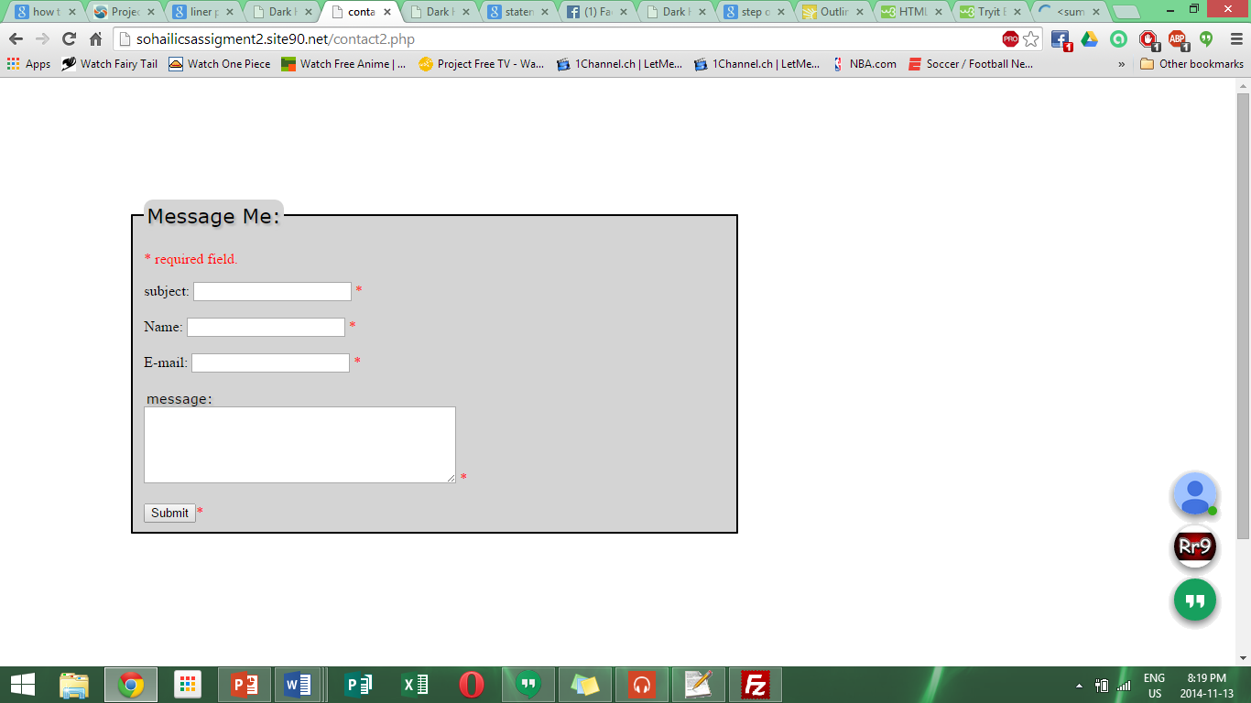

## Java script slideshows:

Initially multiple java script slideshow source code plus some jQuery where used to build a complex slide show. But due the inconvenient complexity of the code, a simple java script slide show was built, consisting of only 3 functions with the ability to change slide.

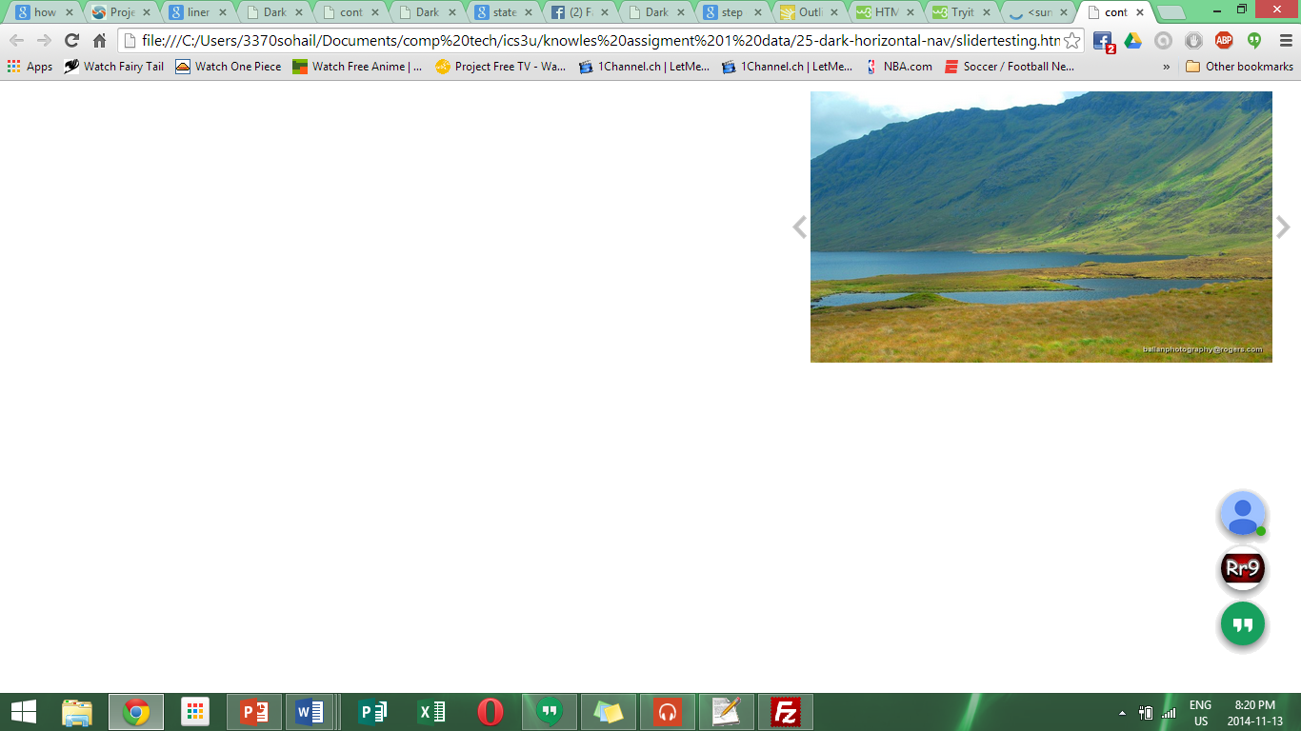

## Nav:

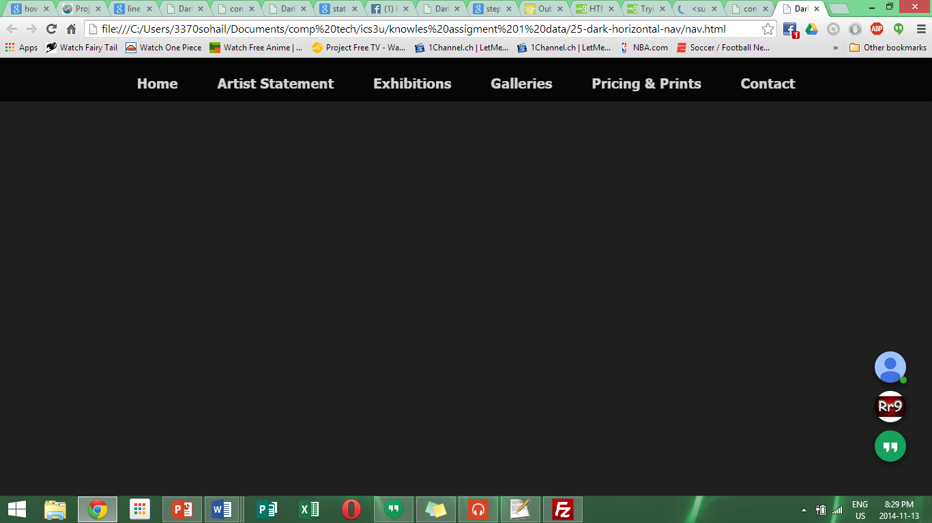

## Footer:

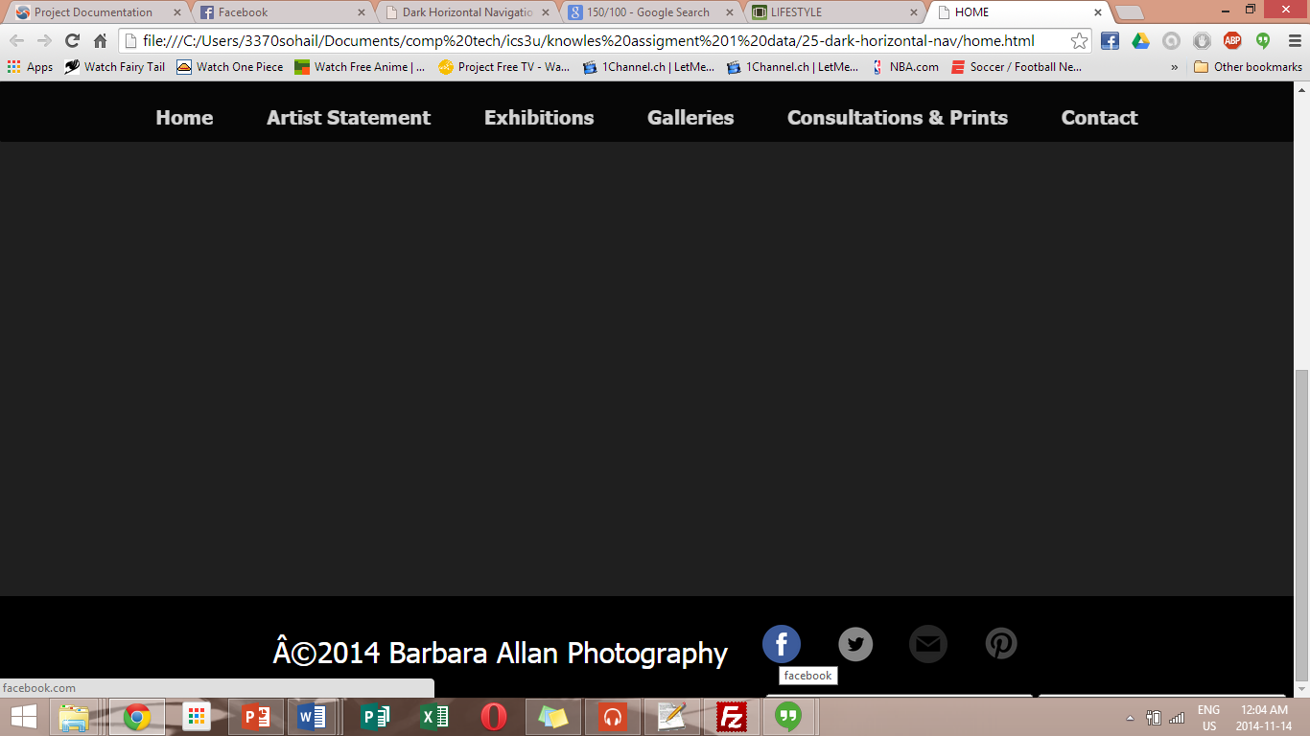

## Drop down testing:

Html summary tags and detail tags where tested with CSS to later be implemented in to the website.

The drop down are used to contain long paragraphs that took up unnecessary space on the site.

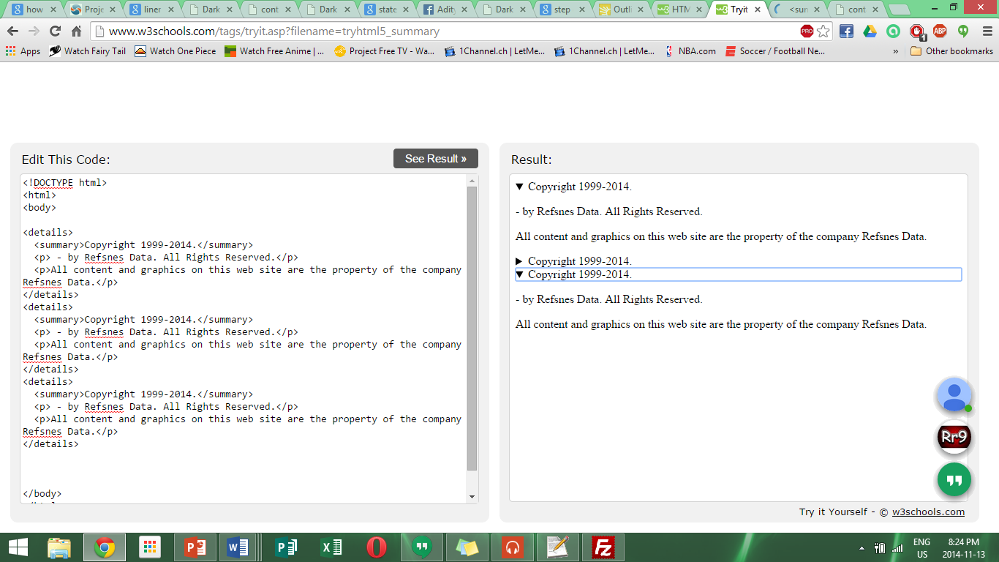

## homepage:

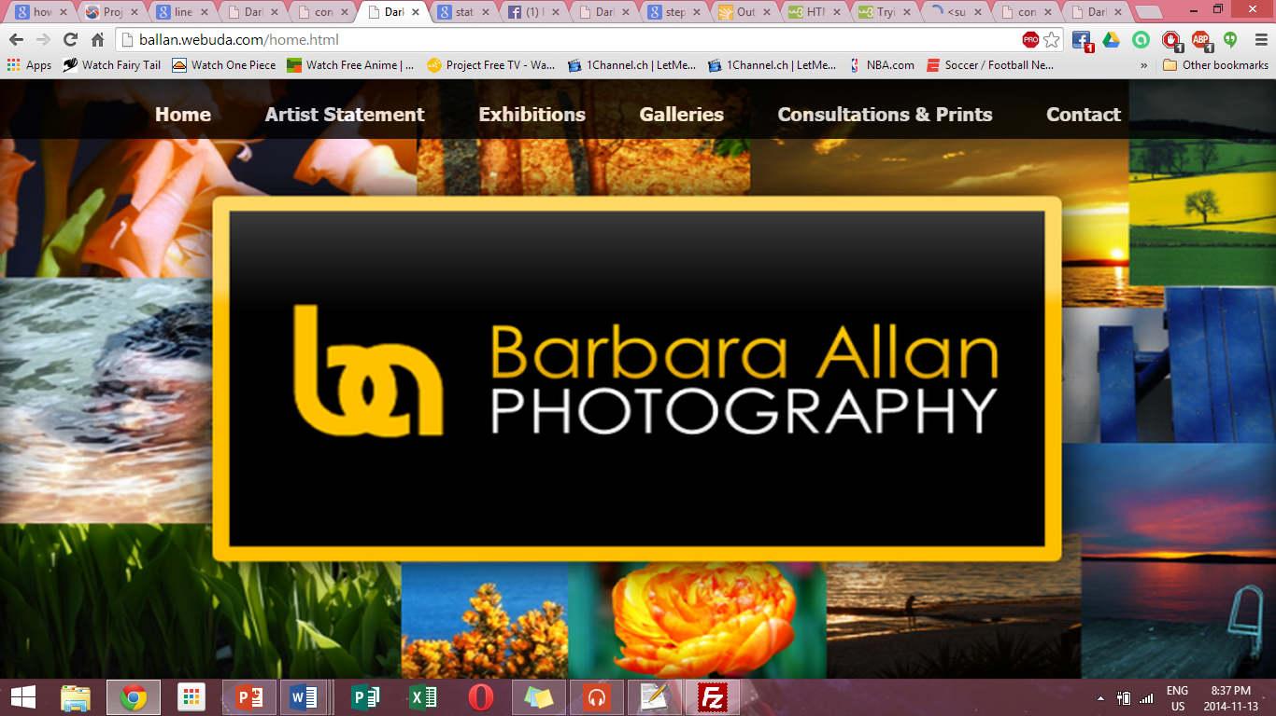

## Artist statement page:

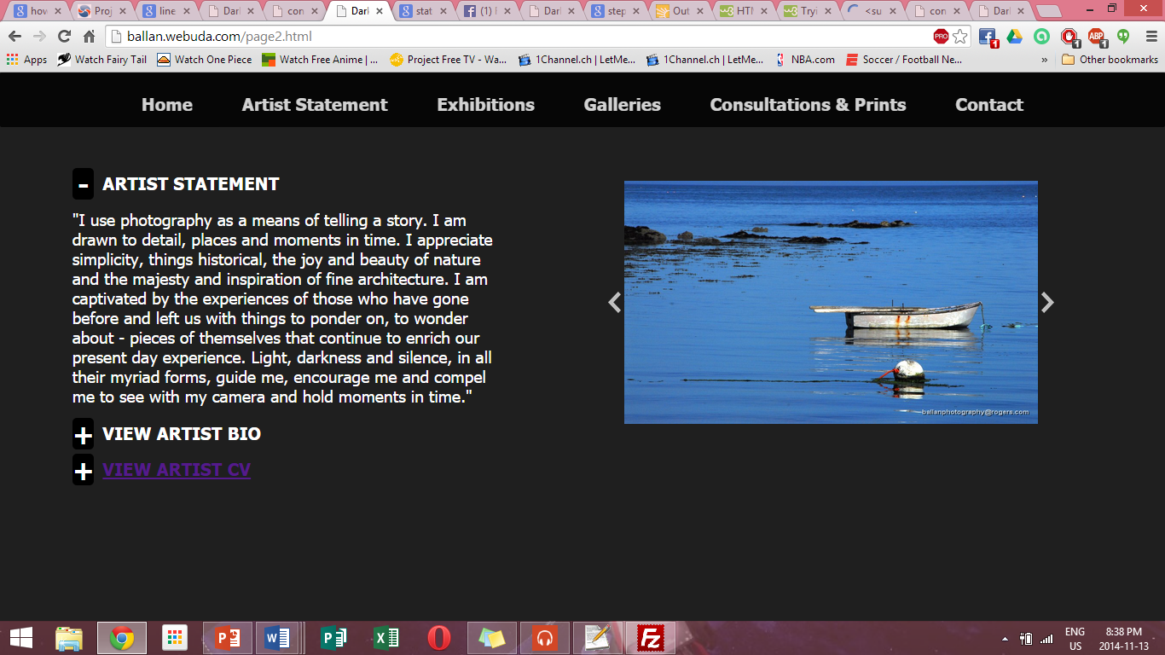

## Exhibitions PAGE:

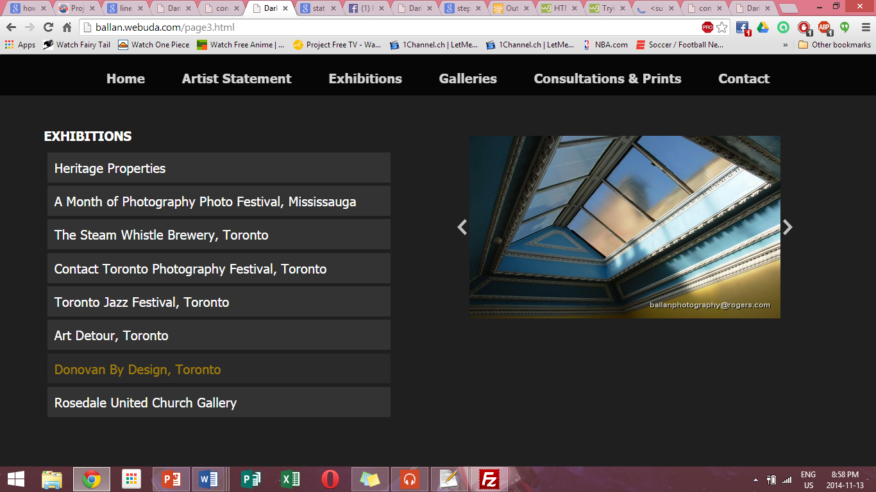

## Galleries page:

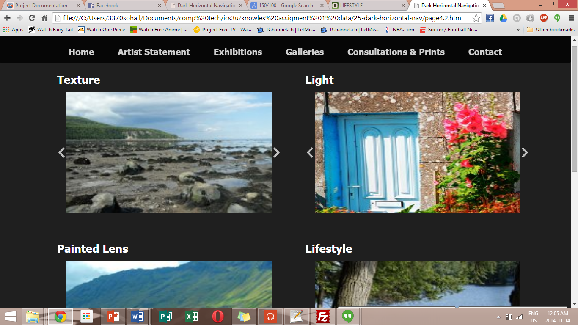

## Consultaion & Prints Page:

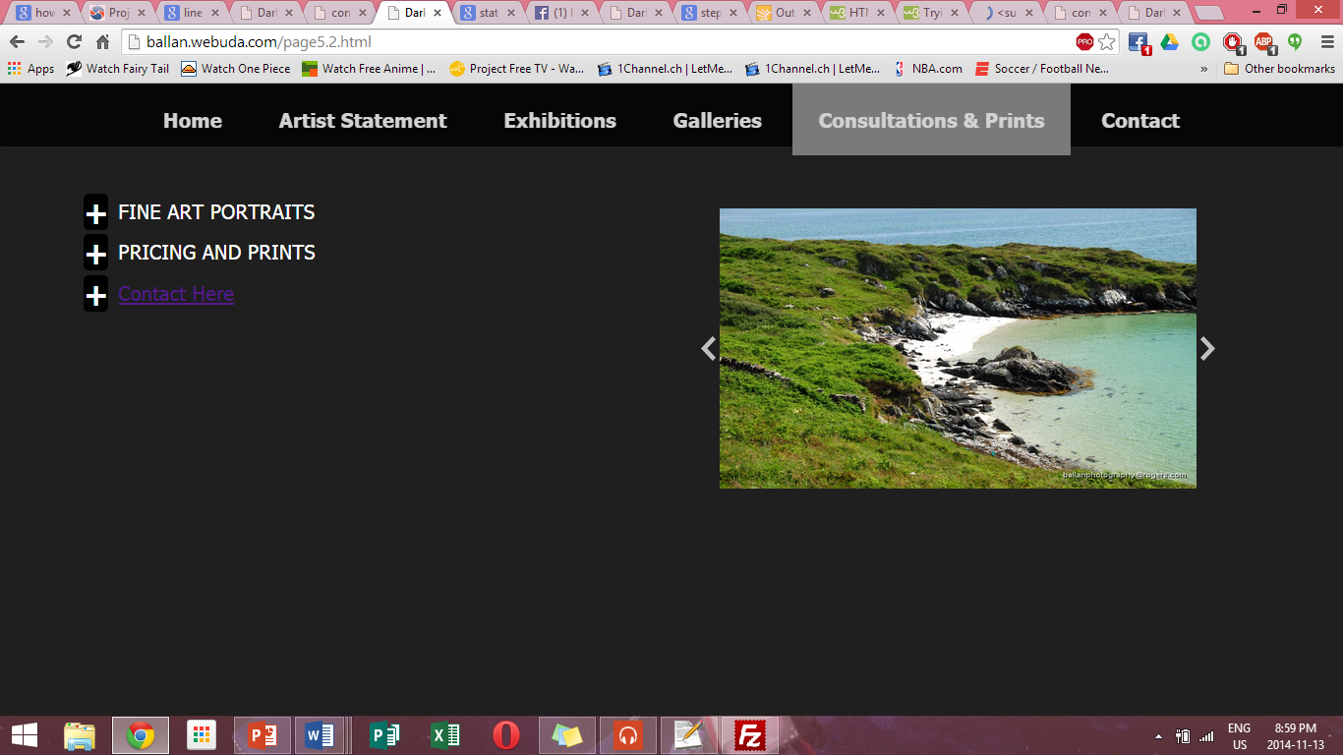

## Contact:

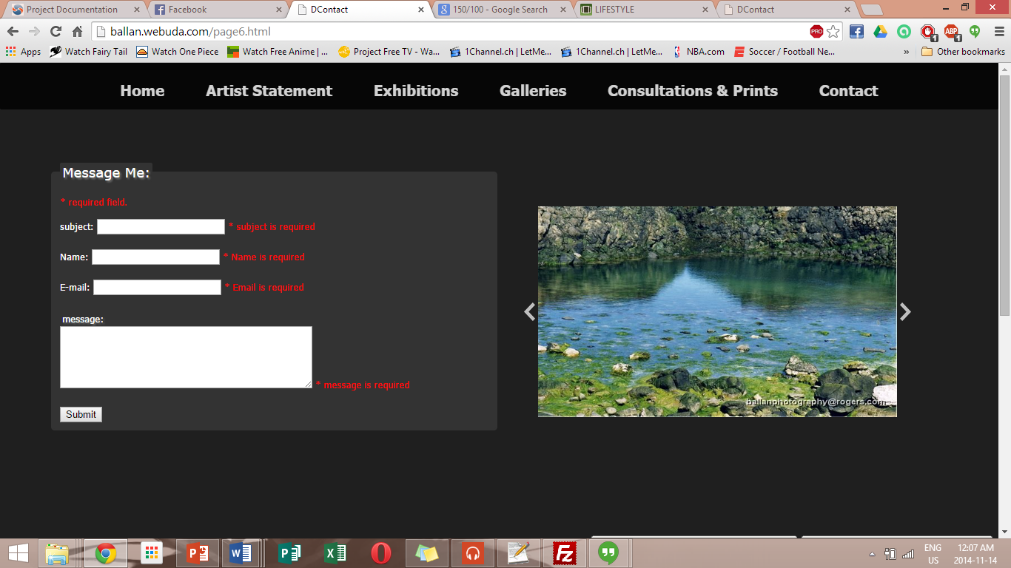

# Key features

## Messaging system:

Sends well formatted emails with the user’s inputs.

### email Format example:

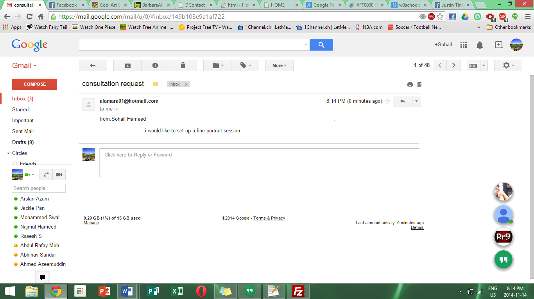

### Sentence case CHECKER:

The sentence case checker insures that the user inputs the proper information in to the forum

Subject: only accepts letter, white space and periods and commas

Name: only accepts letters and white spaces.

E-mail: only accepts a properly formatted email

Message: accepts any input

### honeypot:

The honeypot is an alternative to a captcha for stopping robot inputs and spam; the honeypot was used since it does not require the user to waste their time and input a captcha that prevents robots from spamming the site. The honey pot uses a hidden input which user can’t see but that robot will by default fill using robot framework text file, thus when this input is filled the robot will be redirected to another page.

## Slideshow galleries

### continuously rotating images:

Use two simple Java script functions to rotate the image on load of the screen



### Previous and next buttons:



These button allow users to skip images in the slide show or go back and look at one they might have liked and would like to order.

## simple drop downs:

The drop downs allow for less clutter on the page and which makes the reader compiled to stay on the page and expand the drop down. Thus user actually reads the page and dose not glimpsing over it.

# Conclusion

## Beta tester review:

Overall after the site had been presented to some beta tester (select member of port credit secondary) it receives good reviews. The tester all found the site very simplistic and easy to use, many people commented that the ability to change the image of the slide show was a nice touch. The testers also commented that the messaging system was very nice and that they liked how they did not have to input a captcha. Although a few people expressed some concern as to how you could send an email use anyone’s email address and it would send the email under that email address. In addition the tester felt that there should be a limit to the amount of emails a user can send, but when this feature was talked about with the client she did not approve of it. The site got very nice reviews and has appealed to people for is slick and simplistic design.

## next steps (if contract is renwed):

Upon renewal of contract many things can be add if the certain restraints are lifted from the client’s requirement.

### Reviewing section:

This page will feature a forum that allows people to review the client’s photos and rate them. Since this requires a data base this could not be implemented in this website.

### wedsite Search:

By using a data base a search can be implemented on the website so that user can search for images, pricing and other such things.

### Message LIMITING:

This will allow users to only send a certain number of messages and when the client has looked over their email, they would just go to the site and uses their code input on the massager and rest the limiter.

# Index

## Figure 1.

